

College of Business Administration
Cooperative Education Student Report

co-up training in Almosleh group
( department of finance )

Submitted to
Dr. Ayman Zarban
Department of finance

By
( Mousleh AL-shaker )
In Cooperation with ( Dr. Abdullh Almosleh group )
( bohoor alshoara – khalidiya Jeddah 8854-233423 )

In Partial Fulfillment of the Requirements
of Bachelor Degree in finance

Date dd/mm/yy

Name: Mousleh AL-shaker
Major: Finance
Fall /2020
Employer: Osamah almosleh
Employer’s location: finance administration

CO-UP TRAINING IN ALMOSLEH GROUP
( DEPARTMENT OF FINANCE )

"I have read this co-op report and agree that it contains no proprietary information, and it may be submitted for the Cooperative Education Program at UBT.”

Site supervisor’s signature: _________________ Title: _____________________________
Site supervisor’s name printed: _______________
Site supervisor’s email: __________________
Date signed: _______________________

Below the academic advisor's information, including the following completed checklist:

COOP REPORT COMPLETION CHECKLIST:

____ Report is in its proper format.
____ Report sources are properly documented (if applicable).
____ Updated resume is submitted with report.
____ I have an additional copy of the student report for the department records.
Certified and Approved by:
Academic advisor name printed: _______________
Academic advisor Signature: ____________ Date signed:__________________
Approved by:
Head of department: ____________________________
Date signed: ___________________________

Chapter 1 – The organization

Introduction:

Al-Mosleh Law Firm, Documentation and Arbitration Office was established in 1431H with number 38/728. Since its inception, it has become a destination for individuals, companies, business owners and investors, because of the services it provides that adhere to the highest standards of professionalism and are based on the sincerity of advice and the imperative of keeping clients' secrets. Today, after more than ten years since the office's establishment, it has an advanced position among its counterparts in the Kingdom of Saudi Arabia. It has become a destination for legal services seekers of various classifications and in multiple fields.

Departments of the firm:

- Business and trade organization.
- Systems of companies, institutions and establishments.
- Investments.
- Insurance.
- Intellectual property.
- Franchise rights and license – franchise contracts.
- Real estate ownership.

Training process:

I begin training in the Almosleh group from 1/1/1442H TO 1/4/1442H in the department of finance, and I have five sections:

- Employee’s rights and organization rights.
- Programs course.
- The task of finance.
- Meeting.
- Outdoor tasks.

And its take three months to finish our training program with supervisor: ---------------
Department of finance: --------------

It was excellent work with them for more experience. And I learned how we work individually or in groups, how we respect work times. Respect your manager and all employees. I learned new things every day. Improve yourself by courses and training. The best way to be a successful employer its work for the organization's mission & vision.
Employee’s right and organization rights

Introduction:

When you work in any firm, there are many rights for you and from you .it is protect you from any actions or punish you didn't do. It is safe your rights from anyone in that organization; also, there are rights for the organization to they can do the mission and vision under the law of the business court.

Rights of an employee:

Workers’ rights include; not being victimized or not being beleaguered. They should also not be treated less favourably because of either religion, colour or race. Such a right pertains to gender identity, sexual orientation and pregnancy, disability and national origin.

Employer and employee rights:

Bosses and their workers have the duty to each other both parties expect their rights to be respected. Such responsibilities and rights are associated with terms and conditions of service, safety and health, and equal chances.

The Three Basic Worker Rights:
All workers have their rights. According to the Ham Commission Report, the following are the fundamental rights of employees: the right to information, the right to refuse dangerous work, and the right to partake.

Organization rights:
There are several administrative organization rights, such as union representatives' right to get time off based on union activities. They also have the right to access workers' premises and the fight to hold union meetings. They also have the mandate to order or stop amenities.
Programs course
Introduction:

It is a course of learning how you can use finance essential programs and how it helps you in your work, and your life investment and these programs are:

- Excel Microsoft.
- Argaam.
- Bloomberg terminal.
- Yahoo finance.

Chapter 2 -Excel Microsoft

Introduction :

Excel learns your patterns, organizing your data to save you time. Easily create spreadsheets from templates or on your own and use modern formulas to perform calculations. New charts and graphs help you present your data in compelling ways, with formatting, sparklines, and tables to understand your data better. Easily create forecasts to predict trends with just a click.

Functions in excel Microsoft :

A function is a predefined formula that performs calculations using specific values in a particular order. Excel includes many everyday tasks that can quickly find the sum, average, count, maximum value, and minimum value for a range of cells.

Functions for finance & accounting:

- The SUM function.
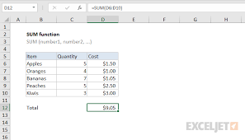
- The AVERAGE function.

- The SQRT function.

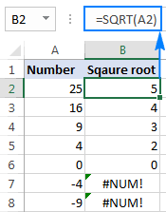
- The SLOPE function.

- The MAX function.

- The LN function.

- The MIN function.

Chapter 3 - Bloomberg Terminal



Introduction:

Bloomberg was hurled in 1981 before the innovation of the internet and computer. Such design is helpful in the financial market as it helps in terms of transparency. Blomberg terminal connects market professionals to analytics, information and data services and transformed this industry.
Markets:

Bloomberg is the basic source of awareness analysis and context. The platform delivers unparalleled securities and market coverage with data on all classes such as equities, fixed income, pashing, and commodities. Also, Bloomberg offers information in real-time, whether on a mobile device or desktop.

What can we found in the Bloomberg terminal, and who?

In the Bloomberg terminal, we can found a lot of news for markets. We can found famous people and rich people who have the biggest companies in the world. Also, there is a lot of exciting information to help us as a financial department.

Ratio:

The ratio is the relationship between two things. A connection between both quantities is basically expressed as the proportion of one divided by the other. A ratio can also be articulated as a percentage or decimal.
Liquidity ratios:

Measure an organization's ability to repay debts requirement and its margin of security through quick ratios, cash flow ratios, and current ratios.

Fixed income functions:

Such income refers to the investment type that pays investors a fixed dividend or interest payment before its maturity. When fixed income investment matures, the principal amount invested is repaid. Corporate and government bonds are the standard types of fixed income.

Fixed income securities:

Fixed-Income securities are debt instruments that pay a fixed amount of interest—in the form of coupon payments—to investors. The interest payments are typically made semiannually while the principal invested returns to the investor at maturity. Bonds are the most common form of fixed-income securities.

Fixed income securities examples:

- Bonds.
- Savings bonds.
- Guaranteed Investment Certificates (GICs).
- Treasury bills.
- Banker's Acceptances.
- Laddered portfolio.

Portfolio:

this Refers to the collection of financial statements such as cash equivalents, bonds and commodities. Other examples of the portfolio are exchange-traded funds, bonds and stocks.
Stock portfolio work:
Such a portfolio is just like a carrier of assets that holds cash, stock, bonds, etc. Financial investors target a return by mixing such securities to reflect the financial goal and risk tolerance.

How you build a stock portfolio:

- Carve out some study time. ...
- Develop a plan and take a long-term view. ...
- Use three parameters when choosing stocks. ...
- Diversify with 10 to 30 individual stocks. ...
- Be choosy. ...
- Establish an investment time frame.

How do I make my portfolio more efficient?

- Identify all the portfolios with similar volatility. The next procedure is sub-setting the portfolios and then select one with the highest return.
- Identify the portfolios that have similar returns. Choose one that has the lowest risk.

Good stock portfolio:

The stock portfolio includes a wide range of potential growth stocks and blue-chip, bank account and index funds.

Three types of portfolio:

There are several types of portfolios, such as assessment portfolios, display portfolios and working portfolios. In practical cases, these portfolios overlap each other.

The best stocks to buy in 2020 :

Amazon (NASDAQ: AMZN)

Amazon is an international technology organization based in Seattle. The Company deals with artificial intelligence, cloud computing and e-commerce, among others.
Alphabet (NASDAQ: GOOG)

This is an American international technology organization that deals with internet products and services. Some services include online advertising technologies, computing cloud and search engine.
Apple (NASDAQ: AAPL)

It is an international; technology organization found in Cupertino that develops, sells and designs online services, computer software and electronics.

Costco (NASDAQ: COST)

It is a type of discount store or wholesale club where massive quantities of goods are sold at substantial discount prices to club members who pay yearly membership fees. The Company is among the largest discount store in the world.

Disney (NYSE: DIS)
It is an entertainment company that deals with informing, inspiring and entertaining people around the world.
Facebook (NASDAQ: FB)

It is an online social media platform that deals with social networking. The platform also offers a flagship service.

Mastercard (NYSE: MA)

It is a technology company that deals with the worldwide payment business. The organization connects financial institutions, governments and consumers globally to enable them to utilize electronic payment forms.

Microsoft (NASDAQ: MSFT)

It is the leading developer of software applications and systems and also personal computers. The organization also publishes multimedia titles and publishes books.

The average stock market return is 8%:

In this context, the market means S&P 500.thus the market's long-term average is 8%. The long-term rate is reduced by inflation. as per the need, investors can lose 2 or 3 percent of purchasing power due to inflation.
The most important ways to invest your money

- High Yield Emergency Fund :

In a high-yield savings account, you're paid to save. Online banks tend to deliver the most competitive yields for these accounts. The money in your emergency fund grows through compound interest. Currently, you can still earn around 1.3 percent annual percentage yield (APY) at an online bank.

- Real Estate Investing (REITs) :
REITs involve real estate funds traded as units in the capital market. Such real estate investing is essential in distributing the portion of net income to unitholders, mostly in cash annually.
- Peer to peer lending :

This type of financing offers connection to entities or people willing to loan money with businesses or people who need to borrow money. This serves as an alternative to funding old-style. Financing organizations create online platforms that tie investors with loan applicants. The lenders consider the income, credit history and credit score to lend the finance.

- Diversify your money with ETFs :

ETFs, offer stockholders exposure to several asset classes within a single ticker. Such funds differ in risks profile and investment objectives. However, ETFs invest in fixed-income securities and equities.

- Pay down your debt :
There are several ways one can use to pay off debts. Such as the creation of budgets and beginning with paying off the expensive debt. Under the circumstances that an individual can access more money, it is advisable to pay the minimum balance. It is also crucial to take advantage of a balance transfer since dept. Repayment is challenging; one should stop credit card expenditure. Besides, it is essential to delete any online information regarding personal credit cards. Another way of paying debts is putting work bonuses towards balances. Lastly, one can pay debts by selling unwanted household items and gifts.

- Invest in your kids' college education.

Blomberg analyze

Risk analysis:
This process involves examining objectives and project outcomes that may change as a result of the risk event. After risk identification, critical analysis is undertaken to identify quantitative and qualitative impacts of the project's risks.
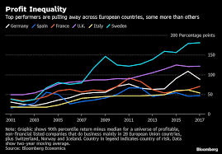
Profit analysis:

This is a form of cost accounting utilized for short ran and instruction decisions. This form broadens the utilization of the information provided by the analysis. The crucial point of this analysis is the point where total cost and revenue are equal.

Financial analysis :

This process involves evaluating budgets, projects, and business transactions to determine their suitability and performance .is also used to analyze the stability of an entity to permit monetary investment.

Chapter 4 - argaam program



Introduction:

It specializes in following up the Saudi stock market, Tadawul - TASI - with in-depth coverage of petrochemical companies and prices, financial reports for new IPOs.
And give us news about what’s happened in the Middle East on time and give us faces the markets. All the markets are flowing TASI.

Tadawul :

It is the only sole entity permitted in Saudi Arabia kingdom to act as the security exchange.Tawadul deals with trading and listing in deposit and securities registry of ownership of securities traded on the business and settlement.

The owners Tadawul:

Sarah Al-Suhaimi (Chairman) Khalid Abdullah Al Hussan (CEO) .

The number of companies in Tadawul:
Tadawul enables access to institutional and individual investors. The tola number of organizations listed, debt issuances and REITs at the end of 2019 was 272.
The sixth main sectors to invest in Saudi Arabia at Argaam:

- Information Technology.

- Al Moammar information systems Co.
- Arab sea information system Co.
- Etihad Etisalat Co.

- Construction.

- Makkah construction and development Co.
- Jabal Omar Development Co.
- Southern province cement Co.

- Agriculture.

- Al-Jouf agriculture development Co.
- Tabuk agriculture development Co.
- National agriculture development Co.

- Engineering.

- Bander Network security engineering Co.
- Ben laden engineering Co.

- Healthcare.

- Middle East healthcare Co.
- National medical Co.
- Dallah Healthcare Co.

- Energy.

- Saudi Aramco Co.
- National gas and industrialization Co.

Trading in Foreign Exchange.

Open price:
The price at which securities start trading upon on a trading day in the stock exchange market. The New York exchange market opens strictly at 9:30 a.m. eastern time. Thus its daily opening price is the price of the first trade.

Close price:
A closing price is a tool used by investors to trail its performance on a given period. It is defined as the last price of the stock traded during the day.

Closing adj:

This refers to the number of potential modifications to the purchase price in any transaction. It takes different forms, such as working capital adjustment. The adjustments focus on closing cash, transactional expenses and indebtedness. Transactional costs usually include inventory and account receivable adjustments.

Dividends payout ratio:

This is the percentage of pays to shareholders in dividends. The total amount of dividend ratio paid to stockholders relative o the total income of the organization.

Chapter 5 - Yahoo finance



Introduction:
Yahoo belongs to media property incorporated in yahoo’s network. The network provides commentary on financial reports, press releases and stock quotes. Apart from producing its original content, yahoo offers several online tools for personal finance management. Besides posting original stories from its staff journalists, the platform also provides vast data and information from other websites.
How can you get data for Company?

- Open yahoo finance website.

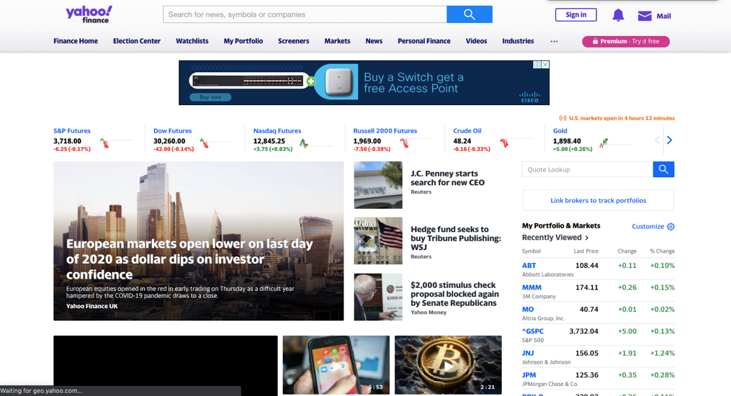

- Search by the name of the Company.

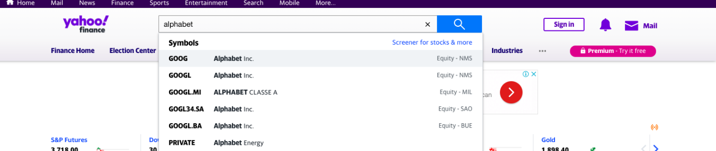

- Choose historical data.
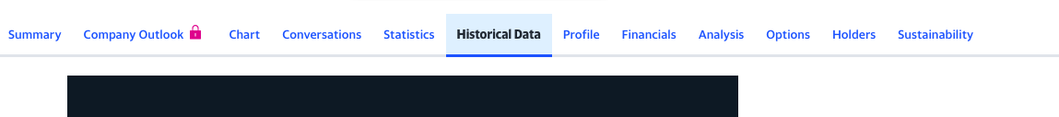

- Put the time from start to end. You can get for daily or monthly and yearly.

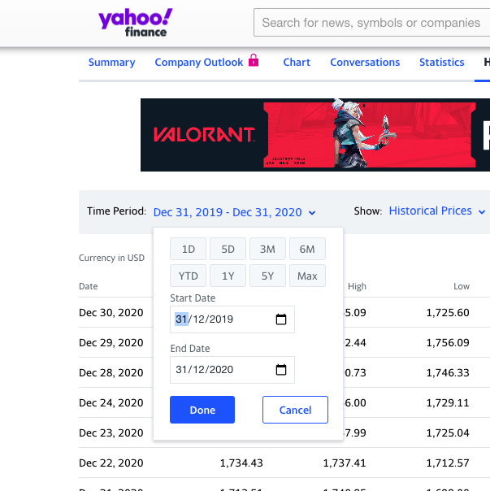

- You will get the data.

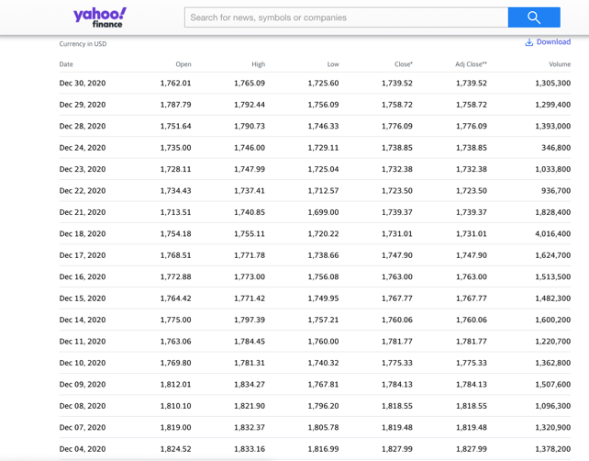

Compare stocks:

- Go to yahoo.com/finance.
- Search for a stock.
- Tap or click Compare.
- In the search box below, enter another stock. Or pick a stock from the "Related stocks" list.

Chapter 6 – Investment
Introduction:
An investment is defined as an item acquired or an asset whose primary goal is to generate appreciation or generate income. The increase in the value of an investment is its appreciation. When a person buys a particular in the acquisition, the main aim is to utilize the good for wealth creation. Some examples of assets include properties, mutual funds and bonds.
The type of investment:

Growth investments.
This is an investment strategy and style that focuses on increasing capital invested by an individual. Different types of investors, such as growth investors, invest in small growing companies to expect the earnings to rise.
Shares.

- Benefits :
The owners of ordinary shares are legible to several benefits such as voting rights, limited liability and gains. Regular shares and dividends are excellent sources of returns to individual investors over a given period.
- Risk :
One of the main risks in investing in shares is the loss of capital.in most cases, negative development and uncontrollable events within the organization impact a portfolio's value and share prices.
Property.
The consistency in real estate outperforms other investments through its increase in value over a given time. Such investment is not vulnerable to short-term fluctuations in the market. Also, there is a possibility of tax benefits for the particular investment. It is always advisable to purchase real estate.

- To start property investment:
When starting your investment, you should first classify your monetary stage and select a particular real estate investing plan. Secondly, you should choose a target market that suits your program. The next step involves deciding your investment criteria and coming up with an effective team. Arrange your financing and raise your cash from reserves and down payment. The last procedure is you should create a plan to locate specific deals.

Defensive investments.
Such an investment requires a plan consisting of regular portfolio rebalancing to maintain asset allocation. Some examples of defensive investment strategies are buying high-quality blue-chip and binds stocks. It also includes holding cash and its equivalents in the market. The last system is differentiating investment across countries and sectors.
- Explain :
There are several examples of defensive stock such as electricity, gas and water since human beings need such utilities in daily business. Companies dealing with such products have an added advantage since the stock interest rates usually are lower.
Cash:

This kind of investment includes saving accounts, term deposits, and money in the bank. Cash investment provides a low level of risk resulting from steady interest payments. Such investment is crucial in reducing the vitality of an individual portfolio.
- The best place to invest cash :

Savings accounts:
This type of bank account is found in credit unions and commercial banks. Saving accounts accrue low interest over a specific period.

Short-term corporate bond funds.
This type of bond is invested with a specific maturity of not more than five years. Besides, any firm can issue short-term debt, including companies and corporations rated below the outlay grade.
Short-term US government bond funds.
Such government bonds focus on bonds offered by the government agencies or government itself, with its maturity set at five years. Example of this bond includes TIPS, MBS and treasuries.

Money market accounts.
This is a specific saving account usually found on credit unions and banks. This account pays high-interest rates and is linked with high-rate market money. However, its minimum balance and deposit requirement are usually high.

Certificates of deposit.
CD refers to a time deposit: a financial product sold by credit unions, thrift institutions and banks. The significant difference between these deposits from savings accounts is that the deposit certificate has an individual fixed interest rate and fixed term.

Cash management accounts.
This type of hybrid account deals with the same features and services of savings and checking accounts. However, they are provided by nonbank financial firms, such as stock firms.
T-Bill.
A treasury bill is a short-term United States debt responsibility handled by the treasury branch. Its maturity is usually less than a year. They sold in small denominations; however, some reaches higher denominations in fair bids.
Fixed interest.
Fixed interests are usually offered by financial institutions, government and semi-government institutions and corporations. Some examples of such interest include capital notes and corporate bonds.
Target markets:

Such a market refers to a group of potential clients to whom an organization wants to sell its services and products; the group is also made up of sure customers whom the Company deals with in its marketing efforts in their pursuit to identify a target market. Target markets:

Market segmentation:

When reaching the entire market becomes an obstacle to many organizations, they utilize target marketing to channel their energy in connecting with defined and specific groups within the market. The major market segmentation is marital status, demographic education, and age segmentation.

Methods of targeting:

Mass marketing (undifferentiated marketing)

Undifferentiated Marketing. This aspect of marketing overlooks significant differences between the market segments and focuses on the entire market. Typically mass marketing assumes that everybody is a potential client.

Segmented marketing (differentiated marketing)
This involves a process whereby organizations create campaigns that attract more than one target group or market segment. A business can promote a specific sale that appeals to individuals in two locations and cities.
Concentrated marketing (niche marketing)
Its unique preferences and needs characterize niche marketing. Such predilections and requirements make it dissimilar from the market, for example, shoes for nurses.
Micromarketing:

This is a marketing strategy in which the primary focus is to advertise and market to a small group of individuals of tightly aimed clients. For instance, markets can be arranged into smalls clusters regarding readiness to buy a particular brand or commitment to a specific product or service class.

Chapter 7 - Tasks



Task 1:

Work on salaries of employees for Company. Should we make it more or less?

I saw the salaries, they give for employees two sections:
1- Salary 10,000.
2- Percentage 15% (if he or she win case in court)

I saw a lot of employees depending on salary so my decision was (makes the salary less and make the percentage more)

The salary 10,000 and percentage 15% so should we do (7,000 for salary and 20%)
With that the employees will marketing for them Company and they will find more customers because they will arise them income.

Task 2:

What the best way to investing our profit and what our revenue from that?

my decision is ( after I saw your financial statement and it was good from 2014 to 31/10/2017 it was perfect from 31/11/2017 to 31/4/2018 it’s fall because the office not having more work and the salary for employees was high also expenses for logistics also high .. after that from 31/5/2018 to 31/2/2020 it was arising after that covid-19 effect them so hardly and them loses arrived 46% from them capital and they back to 25% and this good back in the short time so now my decision for investments it’s have three options :

- Stocks which give you low or stability profit with 0% risk. Because in this moment the market unstable.

- Investment by buy lands and you will achieve profit usually 10% and more sometimes from general price every years. Or your assets still not down from general price also don’t need for expenses.
(This long strategy) .

- Open another projects and this give you expansion on your business ( but we need to studies each proposal project alone to choose what perfect market we investing on .

Task 3:

Three cases in court for customers didn’t pay them money for the firm:

(I suggest to schedule it and I schedule for them- take approval from court) I give them the schedule.

Task 4:

Company value:

Group issue me and my partner in department:

And they give us support from department manager to ask about anything or send any employee for outside to bring information.

They give us financial statement for liability and assets and we should give them financial report about them Company worth in market: we do deprecation for everything machines and cars and we search for price for them assets right now (buildings - lands - them rights from customers - other things) expect expenses to end of 31/12/2020. We start with the final part of company value (them office rights and other things can we selling). Then we begin with (lands and buildings) we finished but the market for lands and buildings it’s unstable.

Concluding:

This experience gives so match information in business work especially in finance section. And you cannot work in the international markets without using international market tools. So, programs like Argaam and Bloomberg terminal it’s give you analysis for markets and how you can take your decision to success in investment. And tasks it is so important to have knowledge how and why the analysis markets give you the best opportunity invest your money or bond or any investment you like to invest there . Also, you should think about risk so good because nothing has high return without high risk.

Contents:

Chapter 1 – Organization
Chapter 2 – Excel Microsoft
Chapter 3 – Bloomberg terminal
Chapter 4 – argaam website
Chapter 5 – yahoo finance
Chapter 6 – investment
Chapter 7 – Tasks

References:

- www.Yahoo finance.com
- www.Excel Microsoft.com
- www.Argaam.com
- Bloomberg website

